BUDGET MANUAL
2023-2024
Revised 12/20/22

“Be mindful that we are in the 29th year of limits on our resources resulting in district-wide budgetary shortfalls…please scrutinize all budget requests to ensure a balance of efficiency and need.”

Key Points/Things to Remember:
- Zero-Based Budgeting – Departments and programs should budget only necessary items and are not allocated a fixed amount. Unnecessary items should be scrutinized and eliminated by the principal or department manager. Signature and detail are required with the Object Summary Form. A budget total from one year does not impact the next year, positively or negatively.
- As a fiscal year progresses - If budget savings are made in a department, building principals may work with staff to determine the best use, or District-wide needs may be addressed. Again, since budgeted amounts fluctuate from year to year, in no year should purchases be made to “spend the budget so that it is not cut next year.”
- Technology Purchases – Use the regular PO Form and submit to the Director of Technology. These purchases require technology and B&G approvals based on compatibility and capacity.
- Special Education Purchases – No special education items should be coded to building budgets. Fund 27 PO Forms Should be organized and reviewed by the Director of Special Education.
- Lunches will not be reimbursed for one-day conferences and seminars.
- If mileage reimbursement is being claimed for a trip originating or ending at your home, the mileage reimbursement must be reduced by your normal mileage to/from your home school in East Troy (only miles that exceed your normal trip to/from work are reimbursable).
- Direct employee reimbursements will not be made without the employee signature on the correct form.
- Sales tax should not be paid – we are a tax exempt organization; our form is on our website for use when ordering. Please take the extra time to remove the tax from the order so it is not your personal responsibility for payment. Sales tax will not be reimbursed on direct employee purchases.
- Employee gift cards are not allowed for purchase by the school district. The IRS views gift cards in any amounts as additional taxable income.
- High School and Middle School - Budget for expected revenues and expenditures from course fees, if applicable.
- Remodel/repair to Facilities Form due to building principal by Jan 31st.
- If any staff member has questions or concerns as to the budget process and cycle, please feel free to contact your department head, team leader, supervisor, program leader, building principal, or a member of the district administrative team.

INTRODUCTION 2
DISTRICT MISSION 2
INTRODUCTION 2
LEGAL BASIS FOR BUDGETING: 2
ZERO-BASED BUDGETING: 2
ENROLLMENT PROJECTIONS 3
BUDGET OVERVIEW 3
KEY POINTS TO BUILDING A ZERO-BASED BUDGET 3
BUDGET RELATED FORMS 3
BUDGET SUMMARY BY OBJECT 4
PURCHASE ORDER REQUEST 4
EXPENSE REIMBURSEMENT 4
FACILITY REMODEL/REPAIR REQUEST 4
PURCHASES 4
PURCHASE REQUESTS/PURCHASE ORDER (PO) 4
PERSONAL FUNDS (DIRECT EMPLOYEE REIMBURSEMENT): 4
SCHOOL CREDIT CARD 5
AMAZON.COM 5
LOCAL WALMART 5
LOCAL PIGGLY WIGGLY, MARTIN'S HARDWARE, AND ET LUMBER 5
CONFERENCE OR SEMINAR ATTENDANCE REQUEST 5
ORDERING ITEMS FOR RESALE TO STUDENTS 5
ORDERING FROM DISTRICT FOOD SERVICE DEPARTMENT 5
DONATIONS 5
INSURANCE RELATED ITEMS (LOSS DUE TO FLOOD DAMAGE, THEFT, OR VANDALISM) 5
CAPITAL OUTLAY ITEMS 6
PETTY CASH FOR BUILDING OFFICES 6
RECEIVING 6
ITEMS PURCHASED WITH A PO 6
ITEMS PURCHASED WITHOUT A PO 6
RESPONSIBLE PARTIES IN DEVELOPING ANNUAL BUDGET: 7
BUDGET CALENDAR AND RESPONSIBLE PARTIES 8
ADMINISTRATION CONTACT INFORMATION 8
BUDGETING CODES-EXPLANATION 9
BUDGETING CODES 9
FUNDS 9
LOCATIONS 9
OBJECTS: PURCHASED SERVICES 9
OBJECTS: CAPITAL 9
OBJECTS: NON-CAPITAL 10
FUNCTIONS 10
SUPPLEMENTAL FORMS End of Packet

INTRODUCTION

DISTRICT MISSION
- To ensure and provide 21st century learning, quality teaching, strong leadership, rigorous coursework, and community service opportunities while demonstrating efficiency and effectiveness for the betterment of the students and community.

INTRODUCTION
- In preparing for the budget, the District will continue to focus on attaining their goals and mission by allocating resources, which is measured in dollars. District administration, principals, program leaders, department heads, team leaders, supervisors, and all additional staff play an important role in the preparation of the annual budget.
- The Board of Education and school administration recognizes the instability of the State of Wisconsin budget, and the uncertainty of funding to school districts within Wisconsin. East Troy Community School District will face some difficult decisions regarding possible reduction in resources. Although the goal of the district is to maintain funding for current services, the district will undoubtedly need to make adjustments to the budget throughout the process.

LEGAL BASIS FOR BUDGETING:
- According to state statute, the Board of Education must adopt a budget for a fiscal year beginning July 1 through June 30. Revenues and expenses are recorded in accordance with the Generally Accepted Accounting Procedures (GAAP) in order to receive the state equalized aid through the Department of Public Instruction, and to provide fiscal accountability to the residents of the East Troy community. The budget may be amended throughout the budgeting cycle, but expenditures must be made in compliance with the approved annual budget.

ZERO-BASED BUDGETING:
- “Zero-based budgeting (ZBB) is a method of budgeting in which all expenses must be justified for each new period. Zero-based budgeting starts from a "zero base," and every function within an organization is analyzed for its needs and costs. Budgets are then built around what is needed for the upcoming period, regardless of whether the budget is higher or lower than the previous one.” –investopedia.com
- The ETCSD has transitioned from a modified site based management model to zero-based budgeting. District, building, grade, department and other budget areas create an itemized budget with as much detail needed to defend their requests. Administration then reviews budget items and discusses the justifications of new, old, and recurring expenses. Zero-based budgeting is designed to give an annual review to help fund budget priorities and to see that allocation of resources are changed to meet the needs of our mission statement.
- The graphic below was retrieved from www.deloitte.com on January 4, 2017
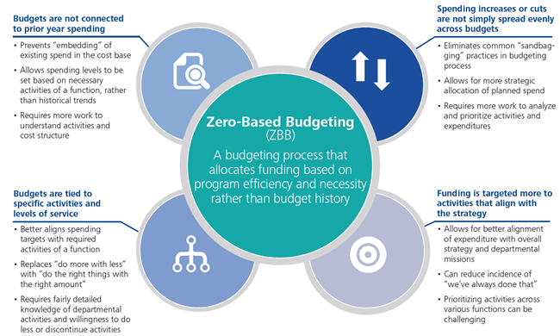
ENROLLMENT PROJECTIONS |  | 2023-24 Zero-Based Enrollment Projection*  Estimate as of December 2022
For the zero-based approach, building/grade level budget leaders should detail individual student costs (i.e. individual subscription costs, supply needs, etc) multiplied times the number of projected students in each grade or class. The building/grade level budgets will use the higher of the current year actual enrollments or the projected enrollments as the basis for justifying budgetary requests. Below is a chart showing the projected enrollment and building allocations for the school year. Grade level detail is available from the building principals or District Office. |  | Level | Count
 |  | Little Prairie Primary School | 330
 |  | Prairie View Elementary School | 280
 |  | East Troy Middle School | 310
 |  | East Troy High School | 473
 |  | *Projection based on a roll forward method from the previous 3rd Friday in September count

To remain fiscally responsible to our community, the district must be aware of the possible changes in revenues and expenses. With the overall budget needs of our district, there is a possibility that zero-based requests may need to be reduced (even as late as Fall of the budget year). The State budget, staffing needs, revenue caps, new mandates, open enrollment, and state aid are just a few examples of subjects that could potentially affect the projected budget as we move through the spring, summer and fall.

The use of carryover fund accounting has been eliminated (use of fund balance). All foreseeable budgetary needs should be detailed during the budgeting process. Decisions will be made at the building, administrative and Board level to fund requests within the context of the District’s overall budget needs and constraints.

BUDGET OVERVIEW
Expenses are either the responsibility of the District, the school building, or individual departments and programs. Monetary responsibilities are subject to change, therefore there may be deviations to the list below.

District | Staff (Salaries and Benefits), textbooks (new upon formal adoption by School Board), district paper and copying
School  Building | General supplies (pens, pencils, paper clips, rubber bands, glue, staplers, staples, markers, tape, tape dispensers, etc.), printer cartridges/toner for printers shared by the building departments/programs, standard classroom furniture and fixtures, replacement textbooks, all 300-900 objects that may be shared by the building departments/programs, laminating expenditures
Dept/Program | All 300-900 objects not considered a general supply or shared by the building

KEY POINTS TO BUILDING A ZERO-BASED BUDGET
- Utilize this manual to fully understand your individual role and responsibilities.
- Complete all forms in a timely manner. Meet deadlines; follow the Budget Calendar located in this Budget Manual
- Disregard all past allocations and build a budget based on future need. All budget line items will need to be justified to your principal or supervisor prior to approval.

In addition, complete the following items:
- Determine department/programs goals in an effort to identify proper expenditures.
- Please use a zero-based budgeting thought process in building department and program budgets. Identify all expenditures in detail and eliminate any items that are not absolutely necessary to the success of your area. Your building principal will scrutinize your budget and assist you in eliminating unnecessary items.
- Identify on the Budget Summary by Object Form, the expenditures projected for your department or program.
- Complete a Purchase Order Request Form, or online via Skyward requisitions, for items needed to start the next school year by the end of May.
- Submit all forms to the building principal on time.
- Attend any and all meetings regarding the budgeting process and cycle

BUDGET RELATED FORMS
The following forms are needed to prepare and complete the budget. All forms are available on the District Staff Forms webpage and at the end of this packet.

BUDGET SUMMARY BY OBJECT
  - This one-page document depicts the budget details of an entire department or grade level. It is to be completed by all program/team leaders, department heads, and supervisors and then submitted to the principal for review. It is imperative that items are coded correctly. Object codes and descriptions can be found in this Budget Manual.

PURCHASE ORDER REQUEST
  - A PO Request is used for purchasing goods/services. The request must be approved by the building principal and then the Business Manager prior to purchase. Please fill out one form for each vendor per order. This form may be used throughout the year to make purchases as well as Ecommerce Skyward.

EXPENSE REIMBURSEMENT
  - This form may be used to reimburse staff for direct reimbursable purchases. Reimbursements require administrative authorization and original receipts. Effective July 1, 2008 the IRS. mandates that there will be NO reimbursement of sales taxes on any reimbursable purchase AND no meals will be reimbursed unless the staff member has an overnight stay (i.e. lunch during a one-day conference is not reimbursable).

FACILITY REMODEL/REPAIR REQUEST
  - This form MUST be submitted for initial approval prior to January 31 annually. The request must be approved by building administration and then forwarded to the Director of Buildings and Grounds, who will then determine if funding will come from the District B&G budget. If the project will not be included in the District budget, it may be added to the individual building budget by the building administration.

PURCHASES

PURCHASE REQUESTS/PURCHASE ORDER (PO)
- The majority of purchases are made via a Purchase Orders (PO). The PO will direct the vendor to provide the goods or services that are needed, in a tax-exempt manner.
- Staff should not be placing orders directly with vendors, instead, staff should follow the Purchase Order Request procedure. PO Requests are to be submitted electronically or paper PRIOR to ordering items. Please do not call and place an order without proper procedure as payment for these purchases is not guaranteed and may result in duplicate shipments. There may be times when a purchase order will not work. When this occurs, please consult your principal for the best course of action.
- Any attachments or back-up documentation need to be attached to the electronic requisition or form. Once the PO Request is properly completed with building administration approval, the District Office generates a PO and places the order with the company. If an employee chooses to purchase through a vendor that has not been qualified with the District Office, the employee will be notified to change vendors or the vendor may be added to the system via the District Office.
- All order items are shipped to the person who submitted the PO and their appropriate building. Immediately check that you have received all items listed on the PO, free of damage. Next, send the packing slip/receiving paper to Accounts Payable with your initials that the items have been received. Once Accounts Payable receives the packing slip and invoice, payment will be processed. If Accounts Payable does not receive the initialed packing slip, they will send a copy of the invoice to the receiving staff member to confirm that all product was received. If this occurs, the invoice must be returned to Accounts Payable as soon as possible.
- PO requests for the upcoming school year may be completed prior to the end of the current school year during the months of April, May and June. These purchases will arrive before the start of the next school year. In addition, purchases can be made at any time throughout the school year with appropriate approvals.
- PO NEEDS PAYMENT ATTACHED: If registration or an item requires prepayment, add a note to the purchase order request instructing the district office to send a check with the purchase order. If there is not a notation, the vendor will not receive payment until after service is received and they submit an invoice. Accounts Payable typically prints checks on Thursdays. Be mindful of this when submitting the PO.

PERSONAL FUNDS (DIRECT EMPLOYEE REIMBURSEMENT):
- Some items may not be able to be purchased with a PO, when this occurs please consult the building administration for the best course of action. Reimbursement cannot be made without proper authorization and sales taxes are not reimbursable. Although direct employee reimbursement (staff purchasing something with their own money and asking for reimbursement) is an option, it is not preferred. For proper authorization, a purchase order request must be generated prior to purchase, with a note that indicates the item will be purchased directly by the employee and should not be ordered by the District Office. Upon completion of the purchase, the employee must complete the “Mileage and Expense Reimbursement” form and attach receipts as proof of purchase. Tax-exempt forms are available on the District Website.

SCHOOL CREDIT CARD
- As more and more vendors provide online purchasing options, utilizing a school credit card is an option. Consult the building principal or direct administrator if utilizing their credit card is an option for your purchase. For proper authorization, a purchase order request must be generated prior to purchase, with a note that states “payment will be made with credit card-do not place order”. Once the PO is approved, it will indicate “order not placed”. Check out the school credit card and place the order as stated on the purchase order. Print an order confirmation and give it to the principal/administrator while returning the credit card. Also, email the confirmation or receipt to Accounts Payable as soon as possible. NOTE: Sales tax is not automatically deducted. YOU must contact the online vendor to remove the tax.

AMAZON.COM
- Amazon purchases must be made through the Skyward eCommerce option. Once logged into Skyward, navigate to Financial Management/Purchasing/My Requisition Processing/Requisitions. On the right, click “Add from Online Catalog” and “Amazon Business”. Complete the necessary fields and click “Save and Add Detail”. When shopping on Amazon Business for the first time, you will need to create a login. You can then shop as usual by looking up items and adding them to your cart. Once finished, click “Submit these items for approval”. Upon return to the Skyward screen, click “Add Requisition Accounts”. Select the appropriate account and click Save Account Distribution. To finish, click “Submit for Approval”.

LOCAL WALMART
- The district has a Walmart credit card available for checkout from Accounts Payable, at the District Office. The district will be billed directly for purchases made using the card. First complete a paper PO request, generally detailing what you will purchase and approximate amounts. Once the PO is approved, you may proceed to Walmart and purchase the approved items at the cost listed, with the checked out credit card and tax-exempt card. Return the Walmart credit card, tax-exempt card, and original receipt to the District Office.

LOCAL PIGGLY WIGGLY, MARTIN'S HARDWARE, AND ET LUMBER
- The district has group accounts set up with these vendors for frequent users. The group account allows purchases to be made in store and the invoices are sent directly to the district. If you would like an account set up in your name, contact Accounts Payable. Once a purchase is made, receipts need to be submitted to Accounts Payable as soon as possible.

CONFERENCE OR SEMINAR ATTENDANCE REQUEST
- Please complete a “Workshop Attendance Request” form. Upon approval, you may register for the event and make the appropriate reservations for travel to include hotel/airfare if necessary. Should reimbursement be needed for mileage or any other post-activity, please submit a “Mileage and Expense Reimbursement” form.

ORDERING ITEMS FOR RESALE TO STUDENTS
- Complete an electronic purchase order request using Object 450 (resale). The PO request can be submitted using an estimated dollar amount. If you are able to provide the exact cost of each item, obtain a written quote from the company to ensure all costs are included. Attach this quote to the PO request. Orders cannot be placed until a purchase order is obtained. You may call to get details, but do not place the order until you have a PO number to give the company. The district will fax the approved PO unless you indicate that you prefer to pick the items up yourself and to send the PO directly to you. If you collect money from students before or after you have received the items, submit the money along with the PO number to the District Office. DO NOT KEEP MONEY IN YOUR DESK OR OFFICE SAFE. Accounts Payable will pay the vendor directly from the 450 account once notified of receiving confirmation.

ORDERING FROM DISTRICT FOOD SERVICE DEPARTMENT
- An electronic purchase order request should be completed prior to ordering. The vendor name is: East Troy Hot Lunch Program. Submit the PO as soon as possible so that the Food Service Department has enough time to order food, beverage, etc., to complete your order. Please plan ahead. You may call this order in to the Food Service Director. If you call an order in, indicate that on the PO request.

DONATIONS
- The ETCSD is very fortunate to have tremendous support in the form of donations from various parent, community and business groups in the district. The donor group should not issue payment directly to the vendor. This will result in duplicate payments. Submit any donated money to the District Office along with the purchase order request to utilize the donation (note on the PO that items will be purchased through donation). Per Board Policy, donations greater than $100 need Board approval. Should this occur, please contact the Business Manager.

INSURANCE RELATED ITEMS (LOSS DUE TO FLOOD DAMAGE, THEFT, OR VANDALISM)
- Report in writing to your supervisor/principal the item(s) that have been damaged or stolen in order to begin a claim with the insurance company. At the same time, submit an electronic requisition to replace the items that were damaged or stolen (please make a note on the requisition that it is insurance related and the date the incident occurred).

CAPITAL OUTLAY ITEMS
- When ordering capital outlay items, (ie: equipment, remodeling, minor building improvements, and vehicles) $5,000.00 or over, contact the business manager for fixed asset tracking procedures.

PETTY CASH FOR BUILDING OFFICES
- Petty cash should be avoided as much as possible. However, if necessary to reimburse for postage, copying fees, etc. each building will have petty cash available in the amount of $100 to facilitate these small purchases. When the petty cash decreases to $10, all receipts/logs must be submitted to the District Office for reimbursement.

RECEIVING

ITEMS PURCHASED WITH A PO
- The Purchase Order fax sheet or Skyward should be utilized to track the receiving of an order. Once all items are received, any packing slips should be returned with an initialed PO to AP/AR. Once AP/AR receives confirmation, the District will submit payment to the vendor.

ITEMS PURCHASED WITHOUT A PO
- Once all items are received, gather any packing slips, receipts and order confirmations. Paperwork must include a budget code and be signed by building administration. If an administrator’s district credit card was used, not on the paperwork whose card it was. Send all of this paperwork to AP/AR. Once AP/AR receives confirmation, the District will submit payment to the vendor.

RESPONSIBLE PARTIES IN DEVELOPING ANNUAL BUDGET:
The following person(s) will be responsible for the development of the ETCSD’s Annual Budget:

Dept. Heads  Team Leaders  Supervisors | These employees prepare a budget for their particular department to assist principals in creating their building budget. Purchase Order Request Forms need to be completed for goods and services needed in their department and submitted to their building principal. Ultimately, the building principal is responsible for the building budget. Therefore, the department heads, team leaders, and supervisors should follow the directions given by their principal, and complete all necessary forms by the requested deadlines.
Program  Leaders | Program leaders (ex: Athletic Director, Director of Technology, Director of Buildings and Grounds, etc) are responsible for creating and justifying the budget for their respective programs. Program leaders must prepare and present their program budget to the Business Manager for review, the administrative team for initial approval, and to the Board of Education for final approval and adoption.
Building  Principals | Principals are to assist district administration in preparation of the budget by implementing the principles of zero-based budgeting (and scrutinizing all budgets and expenditures) for the efficient operation of the building(s) under their supervision. Principals are responsible for analyzing grade level and department budget requests and compiling the entire building’s budget by approving any capital expenditure deemed necessary. Principals are to review and approve any POs submitted by department heads, team leaders, and supervisors for resources originating from their buildings. Principals must be able to defend all corresponding budget decisions throughout the budgeting process which includes administrative and School Board reviews. Principals are responsible to budget all expenses (Objects 300-900) for their building(s), excluding salaries and benefits.
Business  Manager | The Business Manager is to assist the District Administrator in completing the Annual Budget as well as the purchasing of supplies and objects needed in the operations of the District. The Business Manager is responsible for the proper accounting of revenues and expenditures using the Generally Accepted Accounting Principles (GAAP) and preparing financial statements for the Department of Instruction and the independent financial audit.
District  Administrator | According to School Board policy number 231, the District Administrator “shall annually prepare a budget for the Board of Education based on the educational needs of the district.” The District Administrator is responsible to the Board of Education, students, employees, and the community of East Troy to prepare the Annual Budget.
Board of  Education | At the Annual Meeting, the Board of Education is to review and adopt an Advisory Budget which has been submitted by the District Administrator with the help of additional employees within the school district. This budget, with possible changes, will then be formally adopted in October along with the certification of the tax levy.

BUDGET CALENDAR AND RESPONSIBLE PARTIES
The Board will review the budget based on a function review (i.e. your program or dept will be reviewed individually).
- Building Department and Grade Level budgets should be submitted to Building Principals.
- All other budgets should be submitted to the Business Manager at the District Office

DUE DATE | PROGRAM BUDGET | RESPONSIBLE PARTY
Feb 28 | Building Department | Department Heads
 | Grade Level | Team Leaders
March 1 | Athletics | Athletic Director: Aaron Judd
 | Health Services | District Nurse: Janet Kmiecik
 | Maintenance and Operations | Director of Buildings and Grounds: Andrew Daniels
 | Special Education | Director of Special Education: Amanda Jones
March 28 | Bldg: Little Prairie Primary | Principal: Lindsey Harris
 | Bldg: Prairie View Elementary | Principal: Mark Weerts
 | Bldg: Middle School | Principal: Adam Trindl
 | Bldg: High School | Principals: Stacey Kuehn
 | Technology | Director of Technology: Justin Modrak
 | Transportation | Director of Transportation: Andrew Daniels
March 31 | Curriculum and Instruction  Special Projects and Grants | Director of C&I and Assessments: Amy Foszpanczyk
 | Special Education | Director of Special Education: Amanda Jones
 | All Other Areas Of Funds 10/27 | Business Manager: Kathy Zwirgzdas
April 1 | Current Budget Spending*  Completion Date* | All Staff
May 1 | Food Service | Ruth Bentley (Director of Food Service) AND Business Manager: Kathy Zwirgzdas
 | All Other Funds: 30, 50, 70, 80
 | District Office, Debt Service, Salaries and Benefits, Insurance, Additional Support Services, and all additional budgets not listed | Business Manager: Kathy Zwirgzdas
*All purchase order requests MUST be submitted. Further expenses will be made on an as needed basis for special end of year items (generate a list of those expenses and submit to principals).

ADMINISTRATION CONTACT INFORMATION
Dr. Chris Hibner | District Administrator | hibchr@easttroy.k12.wi.us | 642-6710 x1222
Amy Foszpanczyk | Director of Curriculum, Instruction, & Assessments | fosamy@easttroy.k12.wi.us | 642-6710 x1227
Kathy Zwirgzdas | Business Manager | zwikat@easttroy.k12.wi.us | 642-6710 x1223
Amanda Jones | Director of Special Education | jonama@easttroy.k12.wi.us | 642-6720 x1275
Lindsey Harris | Elementary School Principal (Little Prairie) | harlin@easttroy.k12.wi.us | 642-6730 x2222
Mark Weerts | Elementary School Principal (Prairie View) | weemar@easttroy.k12.wi.us | 642-6720 x3222
Adam Trindl | Middle School Principal | triada@easttroy.k12.wi.us | 642-6740 x4222
Stacey Kuehn | High School Principal | kuesta@easttroy.k12.wi.us | 642-6760 x5240

BUDGETING CODES-EXPLANATION
Below is an explanation of the coding system utilized to complete budget forms and Purchase Orders. The system is based upon the Wisconsin Uniform Financial Accounting Requirements (WUFAR). Although codes can change from year to year based on DPI guidance, please use last year’s codes to set up new budgets.

XX | XXX | XXX | XXX XXX |  | EXAMPLE: 10 – 400 – 472 – 131 000
Fund | Building (Location) | Category (Object) | Department (Function) |  | 10  (Fund) | 400  (Location) | 472  (Object) | 131 000  (Function)
Example represents an expenditure taken from the general fund, at the high school, for workbooks in the Ag dept.

BUDGETING CODES
Those items that appear BOLD in the following tables are those most commonly used.

FUNDS | 10 | General Fund | Majority of district transactions, unless there is another specific fund related to the transaction.
 | 27 | Special Education | Fund is used to account for special education and related services.
 | 50 | Food Service | Fund is used to record revenues and expenses related to food service activities.

LOCATIONS | 100  Little Prairie | 300  Prairie View | 200  Middle School | 400  High School | 800  District Wide | x81  Grant Funded

OBJECTS: PURCHASED SERVICES examples
Purchased Services Objects include amounts paid for personal services rendered by personnel who are usually NOT ON THE PAYROLL of the District, and other services which the district may obtain from private agencies. While a product may or may not result from the transaction, the primary reason for the purchase is the service provided
310 | Personal Services | Personal services, by their nature, can be performed only by human beings, usually with specialized knowledge and skills. ex: consultants, athletic officials, contest judges, assembly speakers, etc.
313 | Repair of Equipment | Repair/maintenance of equipment used in the classroom
342 | Employee Travel | Travel expenses of district employees on district business, ie: mileage, meals, lodging, and incidentals
353 | Postage | Expenditures for postage
355 | Telephone | Expenditures for telephone line charges and long distance calls

OBJECTS: CAPITAL examples
Capital Objects include items of permanent or enduring nature that cost $300 or more and which are of value for a period longer than the fiscal year in which they are acquired, and which are usually easier and cheaper to repair than replace
551 | Addition of Equipment | Expenditures for the addition of equipment
561 | Replacement of Equipment | Equipment, including vehicles, meant to replace existing equipment not increase total inventory
571 | Equipment Rental | Securing of equipment for temporary use
940 | Dues and Fees | Includes dues and fees of various kinds. ie: Student association fees, conference fees, forensic dues, and fees for field trips that are not being reimbursed with collected funds from students

OBJECTS: NON-CAPITAL examples
Expenditures for all supplies, materials, and non-capital equipment items are recorded here, including freight and handling costs. Supplies and materials normally are used up or consumed in the educational process. A supply is normally expendable; that is, it is usually more economical to buy one than repair it. Tools purchased individually (not in sets) are considered non-capital objects and should be recorded in the appropriate accounts.
411 | General Supplies | Classroom, athletic, office, library, and custodial supplies as well as small tools
413 | Computer Supplies | Blank CDs, thumb drives, or other consumable computer supplies. Use Object 417 for computer paper
415 | Food  (only FACE dept.) | Food used in instructional programs intended for human consumption, whether in prepared condition or not at the time of purchase, ie: meat, vegetables, baked goods, milk products, beverages, candy, etc.
416 | Medical Supplies  (only nurse/athletic) | Disposable items for use in diagnosing and/or treating physical or dental conditions, such as tongue depressors, bandages, gauze, cold packs, cotton, iodine, etc. Trained medical personnel use this object
420 | Apparel | Items intended to be worn on the human body. Athletic uniforms and protective equipment including goggles, shoulder pads, helmets, etc.
431 | Audiovisual Media | Audiovisual media materials (not equipment) used in the instructional program, ie: films, maps, globes, charts, records, pre-recorded video/audio, study prints, posters, etc
432 | Library Books  (Only Library/IMC) | Books which are purchased in limited quantities (i.e. not a classroom set), AND which are usually kept in a central location, such as a library or IMC. Rebinding and repair of library books is also recorded here
433 | Newspapers  (Only Library/IMC) | Daily or weekly newspapers purchased either singly or by subscription
434 | Periodicals  (Only Library/IMC) | Any magazines or recurring issued publications purchased singly or by subscription
436 | Library Computers  (Only Library/IMC) | Computer purchases for the library. (This code can only be used with 222xxx functions.)
439 | Other Media | Reference materials (book, CD, or digital), including encyclopedias, pamphlets, bulletins, and manuals. May be single reference books or sets of books
440 | Non-Capital Equipment | Items that have the characteristic of equipment, but with a small unit cost (less than $300). Ex: containers, desks, building furnishings, measuring devices, tools, and implements
450 | Resale Items | Non-capital items purchased specifically for resale for various purposes and connected with a specific function, ie: Tech education and art supplies for which the department is reimbursed by the students
471 | Textbooks | Addition and replacement of textbooks (other than library and reference) purchased as standard work for instructional use by pupils. Rebinding, repair, and freight are included. Use Object 472 for workbooks
472 | Workbooks | Purchased usually with a textbook, and often disposable
480 | Non-Capital Technology | Technology related supplies are typically used in conjunction with technology-related hardware or software. Technology hardware costs below the district’s capitalization threshold should be reported here. Non-capital software including “perpetual license” or one-time fee, below the district’s capitalization threshold should be reported here. Could include e-books and apps.

FUNCTIONS - examples

110 000 | Undifferentiated-Elementary |  | 132 000 | Business Education |  | 162 204 | Boys Baseball
110 100 | First Grade |  | 134 000 | Health Occupations |  | 162 205 | Boys Basketball
110 200 | Second Grade |  | 135 000 | Family & Consumer Ed |  | 162 210 | Football
110 300 | Third Grade |  | 136 000 | Technology Education |  | 162 212 | Boys Golf
110 400 | Fourth Grade |  | 139 200 | Work Experience |  | 162 216 | Boys Soccer
110 450 | Fourth & Fifth Grade PBL |  | 141 000 | Health |  | 162 218 | Boys Tennis
110 500 | Fifth Grade |  | 143 000 | Physical Education |  | 162 222 | Wrestling
111 000 | Kindergarten |  | 152 000 | Early Childhood |  | 162 308 | Cross Country
112 000 | 4 Year Old Kindergarten |  | 156 600 | Speech and Language |  | 162 319 | Track
120 000 | General Secondary |  | 158 000 | General Special Ed |  | 172 000 | Gifted and Talented
120 900 | Read 180 |  | 161 322 | National Honor Society |  | 212 000 | Social Worker
121 000 | Art |  | 161 337 | Newspaper |  | 213 000 | Guidance
122 000 | English |  | 161 339 | Forensics |  | 213 200 | Give Me 5
122 100 | Reading |  | 162 000 | Co-Curricular-Athletic |  | 213 500 | Learning Center
123 000 | Foreign Language |  | 162 105 | Girls Basketball |  | 214 000 | Nursing
124 000 | Math |  | 162 107 | Cheerleading |  | 215 000 | Psychological Services
125 000 | General Music (Elem. Only) |  | 162 112 | Girls Golf |  | 219 100 | PBIS
125 400 | Vocal Music |  | 162 116 | Girls Soccer |  | 219 200 | Section 504
125 500 | Band/Instrumental Music |  | 162 117 | Softball |  | 221 300 | Instructional Staff Training
126 000 | Science |  | 162 118 | Girls Tennis |  | 221 500 | Instructional Technology
126 900 | Robotics |  | 162 121 | Volleyball |  | 222 200 | Library/IMC
127 000 | Social Studies |  | 162 124 | Swimming |  | 222 300 | Audiovisual
129 100 | Computer Education |  | 162 125 | Gymnastics |  | 240 000 | Building Administration
131 000 | Agriculture |  |  |  |  | 295 000 | Admin Technology Services

Adding an Expense Reimbursement Request
Go to Employee Access | Expense Reimbursement | Submit Request.
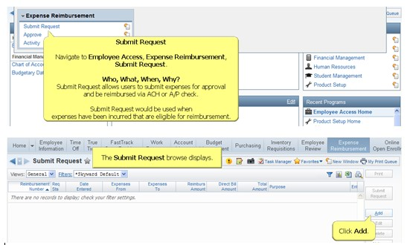
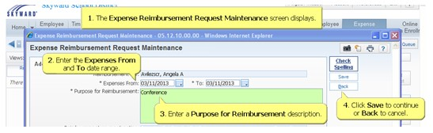
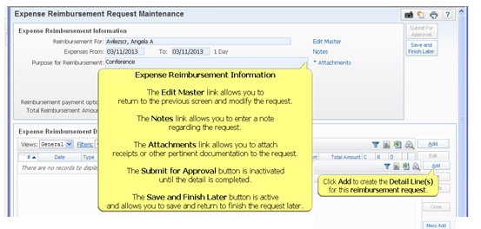
*Required: Attach Receipts
Scan or take a picture and send it to your email, download it to your computer then browse for the document(s).
If you are associated with multiple buildings/depts, you must select what supervisor to submit the reimbursement request to, from the drop-down menu, on the Expense Reimbursement Request Maintenance screen.
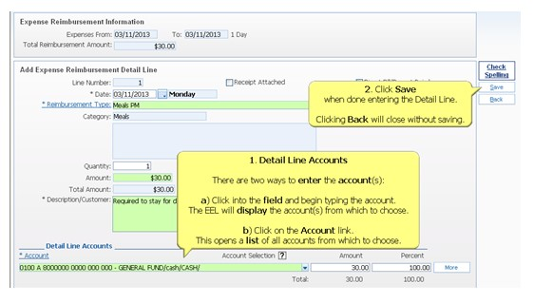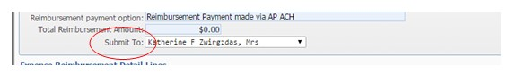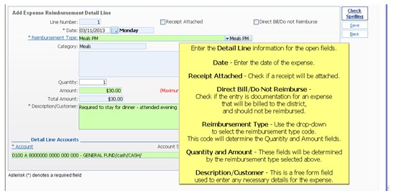
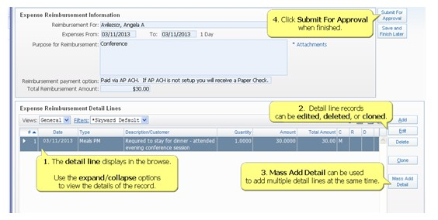
The reimbursement request displays in the browse and is now awaiting approval.

Submitting a purchase Request

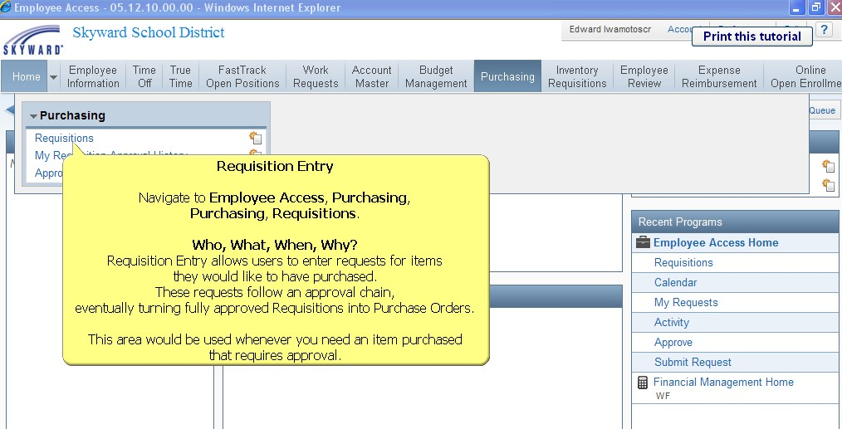

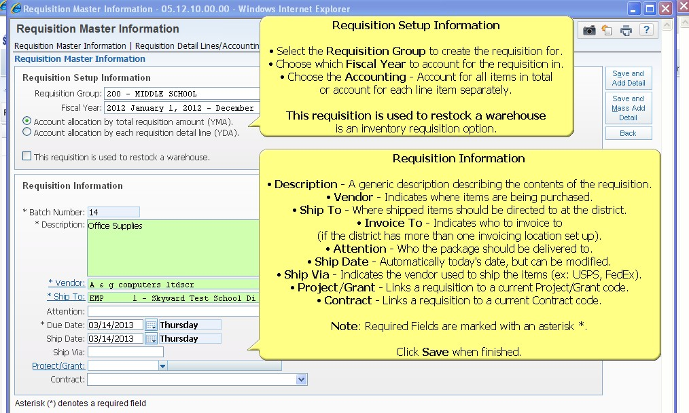

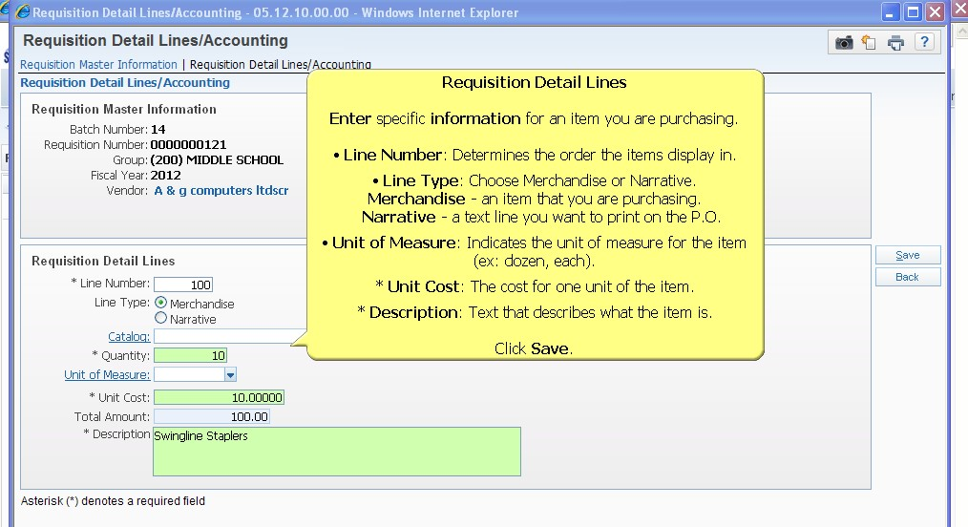

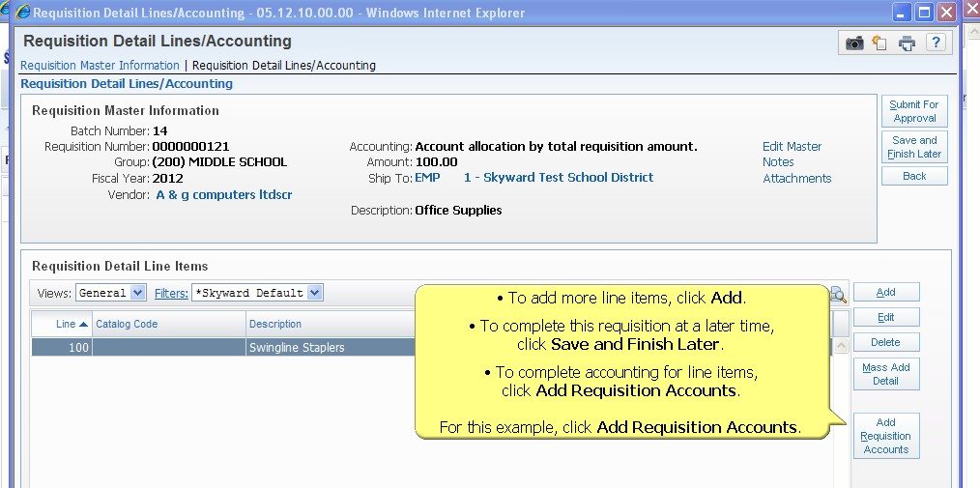

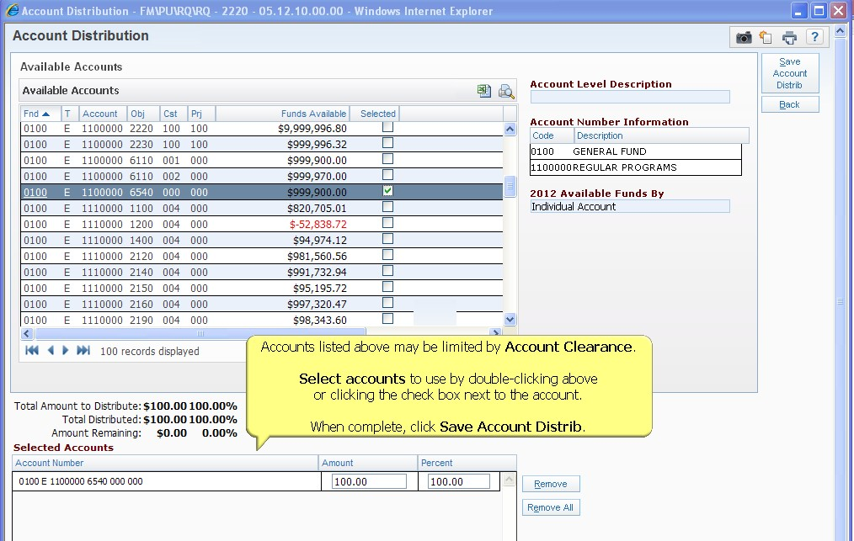
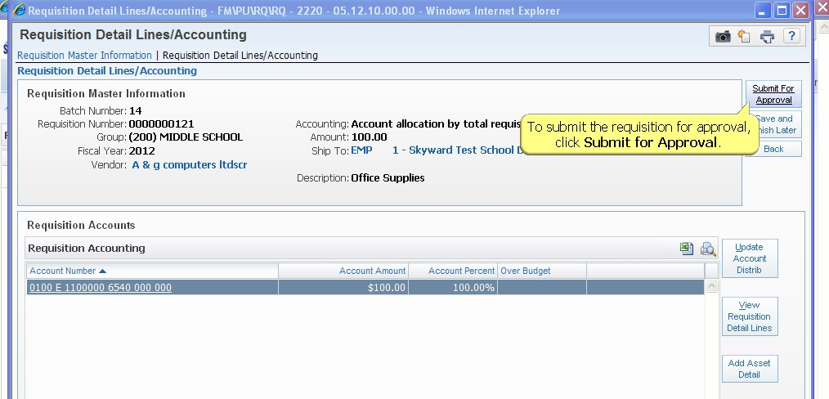

The reimbursement request is now awaiting approval.

